Editing Change Sheet

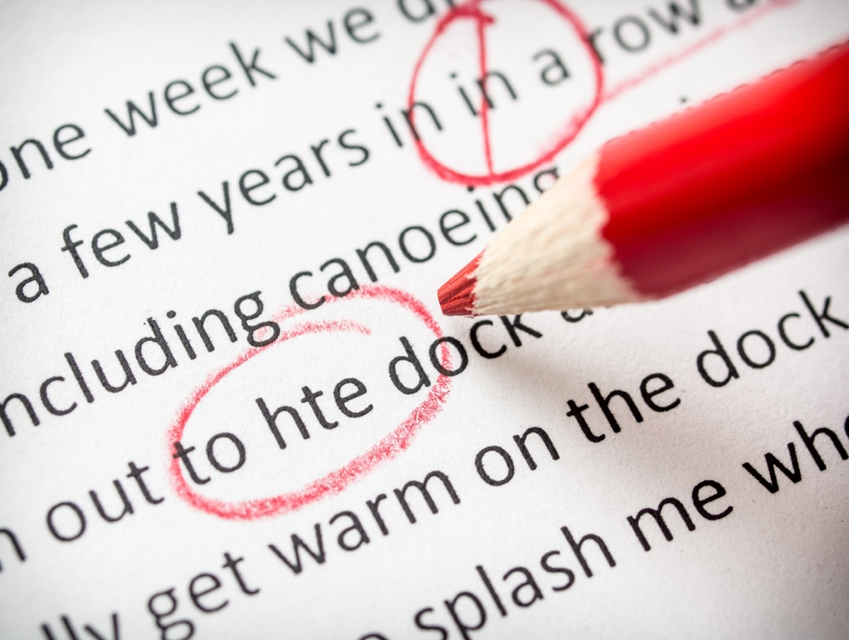

Please insert sample text from manuscript in red for each action required.

Date:
Name of Book:

SAMPLE
Edit# | Page # | Para# | Line # | *Action Required
1 | iii | 3 | 21 | Change 'surly' to 'surely'. Surly, if I could maintain my rigid standards.
2 | 10 | 7 | 6 | Change from 'our' to 'my'. ... blared it from our phone.

Edit# | Page # | Para# | Line # | *Action Required

1
2
3
4
5
6
7
8
9
10
11
12
13
14
15
16
17
18
19
20
21
22
23
24
25
26
27
28
29

Note: To add additional table rows place your cursor is in the last row of the table and click the tab button.

For Office Use Only
Date Received: | Date Completed:
Revision Sheet Number: | Number of Book Versions:
Types:
Revisions per version: | Total number of revisions:
Base Fee: $55.00 | Revision Fee Rate: $0.
Total Revision Fee: $

